

**Capstone Proposal**

**Bug Tracking System**

Name: Zhijian Li

Student ID: 000335374

Advisor: Mark Yendt

Date Submitted:2017-Mar-31



Contents

Background.........................................................................................................................2

Project Overview.................................................................................................................2

Technologies.......................................................................................................................3

Functionality Char...............................................................................................................3

Project Functionality Describe.............................................................................................4

Login Page.............................................................................................................4

First Time Login.....................................................................................................4

Admin – Projects Session......................................................................................6

Admin – Submissions Session.............................................................................10

Admin – Classes Session....................................................................................12

Admin – Users Session........................................................................................18

Instructor – Projects Session...............................................................................22

Instructor – Submissions Session........................................................................27

Instructor – Classes Session................................................................................30

Student – Submissions Session...........................................................................34

Changing Password……......................................................................................38

Database Schema..........................................................................................................41

Test Plan.........................................................................................................................42

Resources and Challenges.............................................................................................43

Project Development Plan…….......................................................................................44

Background

COMP10066 Software Quality and Testing is a course in the Software Support and Software Development programs that is offered in 4th semester. The focus of the course is on improving software quality through testing. The labs in the course are generally submitted in a Word document that contains a list of test cases and a summary of defects (bugs).

One of the topics in the course is bug tracking and includes how to write a good bug report. Currently, this course does not use a bug tracking system for the labs and this has come up during an informal review as something we would like to add to the course.

Project Overview

The bug tracking system will run on CSUNIX that students will use to report bugs in software. The application must only allow a student to see their own results and not others. There will be an administrator mode to set-up student accounts as well and a way to prevent access when not signed on.

Technologies

* Development Stack: **LAMP**

1. Operating System: ***L****inux*
2. Web Server: ***A****pache*
3. Database Server: ***M****ySQL*
4. Programming Language: ***P****HP*

* Text Editor: Sublime/ Notepad++
* Source Control: GitHub/ SourceTree
* Testing Tool: Selenium
* Browsers: Chrome/ Firefox/ Internet Explorer
* Local Server: WampServer

Functionality Chart

|  |  |  |  |
| --- | --- | --- | --- |
| Roles Accessibility | Admin | Instructor | Student |
| Users | F | N | N |
| Classes | RUD | FO | N |
| Projects in Classes | F | ARDO | N |
| Students in Classes | F | RO | N |
| Projects | ARU | AR | N |
| Clarification in Submissions | R | ARO | ARO |
| Submissions | R | RO | ARO |
| Password | U | UO | UO |

Signs Explanation:

A—Add/ R—Read/ U—Update/ D—Delete/

F--Full Access/ N—None/ O—User’s Own Session

Project Functionality Describe

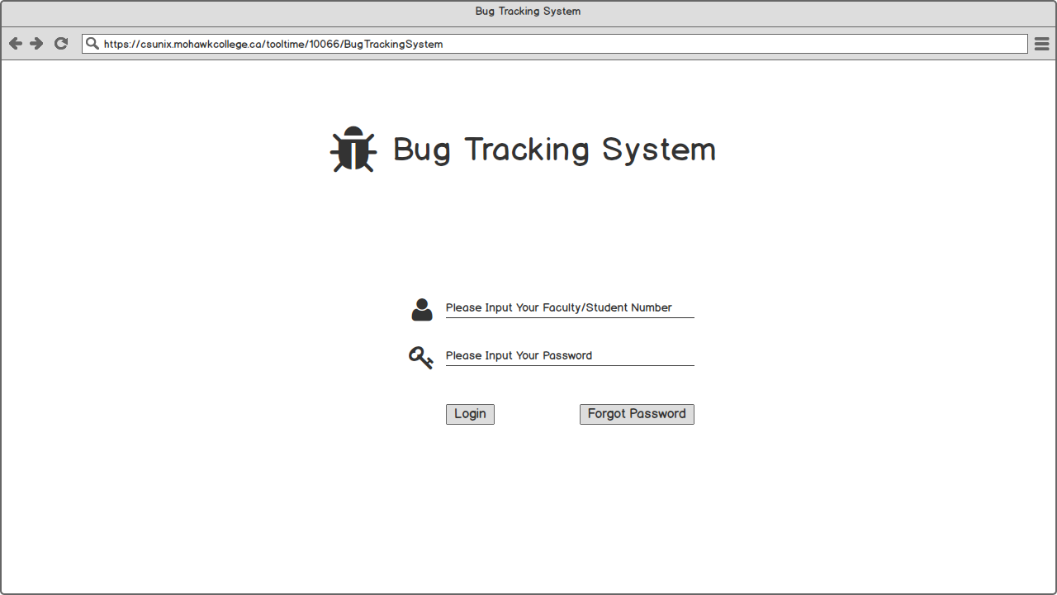Figure 1 – Login Page

Users need to use their ID (faculty/student number) to log in. The initial password will be their ID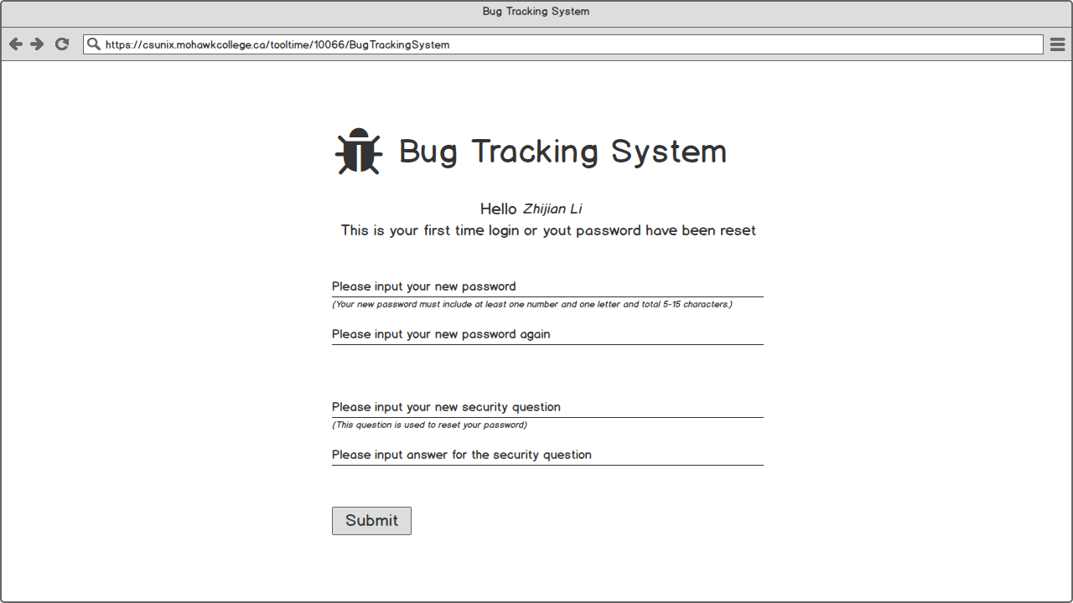Figure 2 – First Time Login

On first login, the user must be forced to change the password and create a new security question. A set of reasonable password rules will be placed on the creation of password.

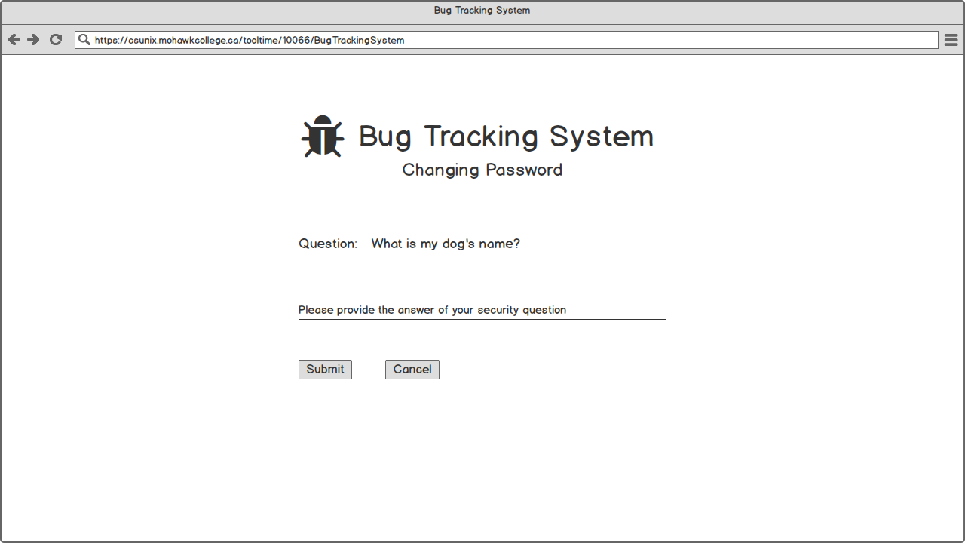 Figure 3 – Answer Security Question

If the user clicked “Forgot Password”, user’s own security question will be showed and user need to provide the correct answer to reset login password.

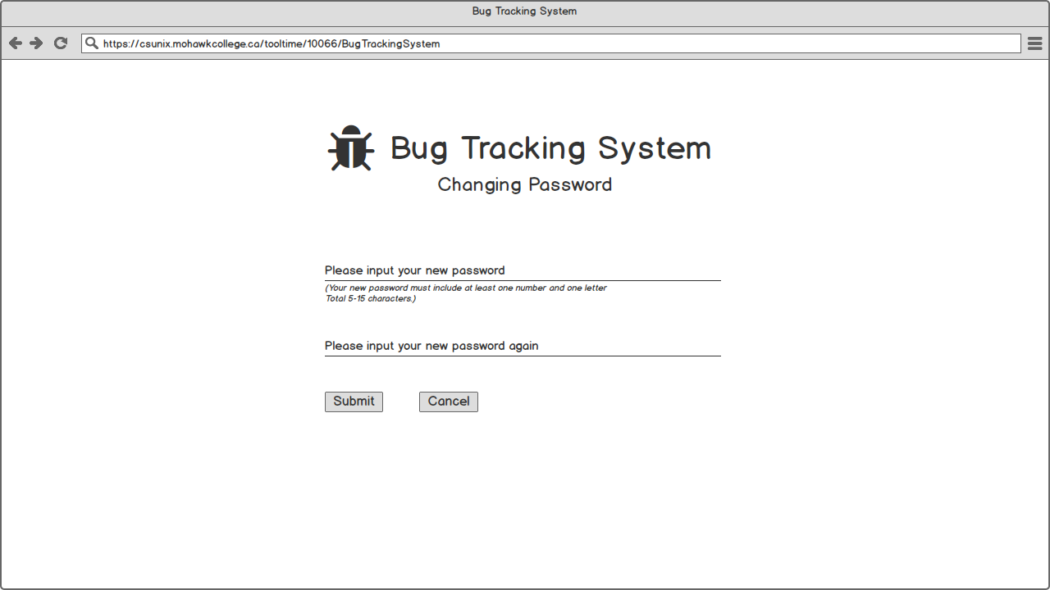

Figure 4 – Changing Password

When the user provided the correct answer, this page is showed.

Admin – Projects Session

Figure 5 – Admin Logged-in (Projects Hover)

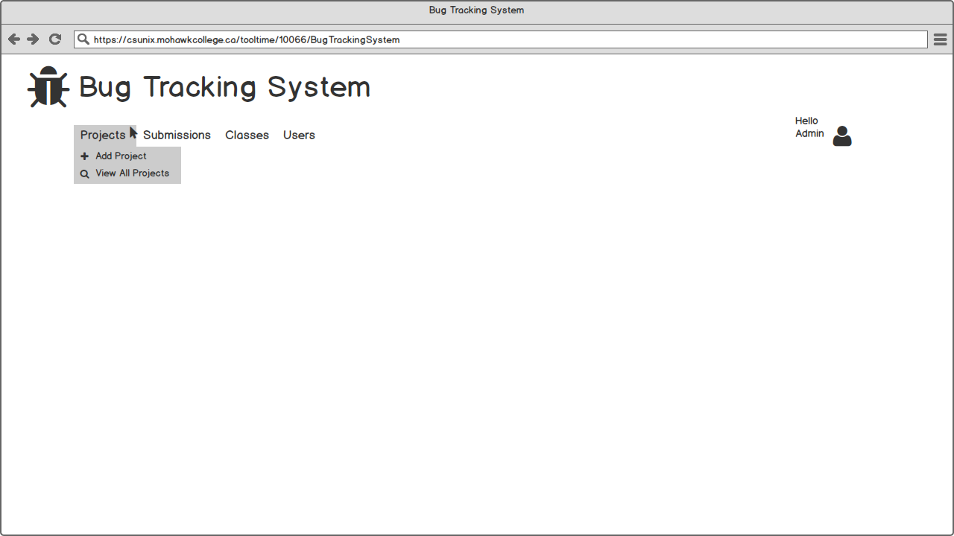

Shows what permission and functionality admin have in Projects session

1. Add Project
2. View All Projects

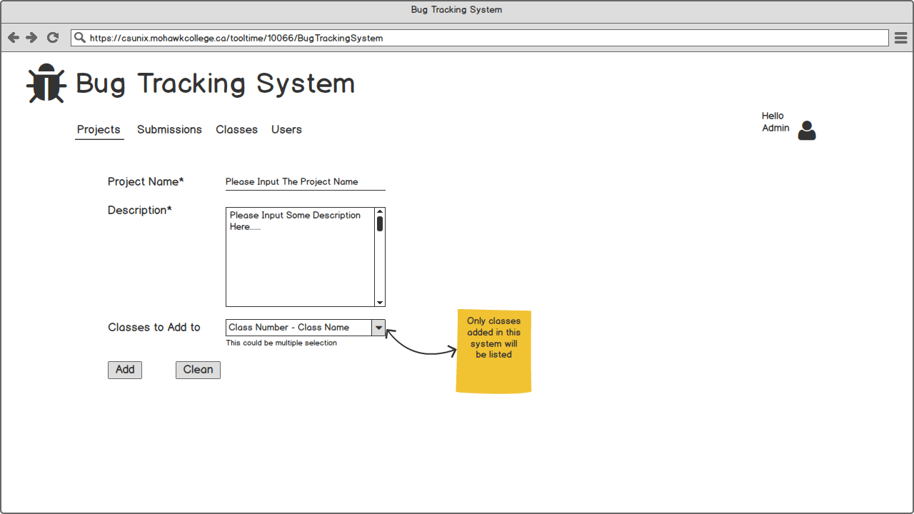 Figure 6 – Admin-Projects Session (Add)

When admin clicked Add Project, a form is showed. Project Name and Description are mandatory field, and the project can be assigned to classes later.

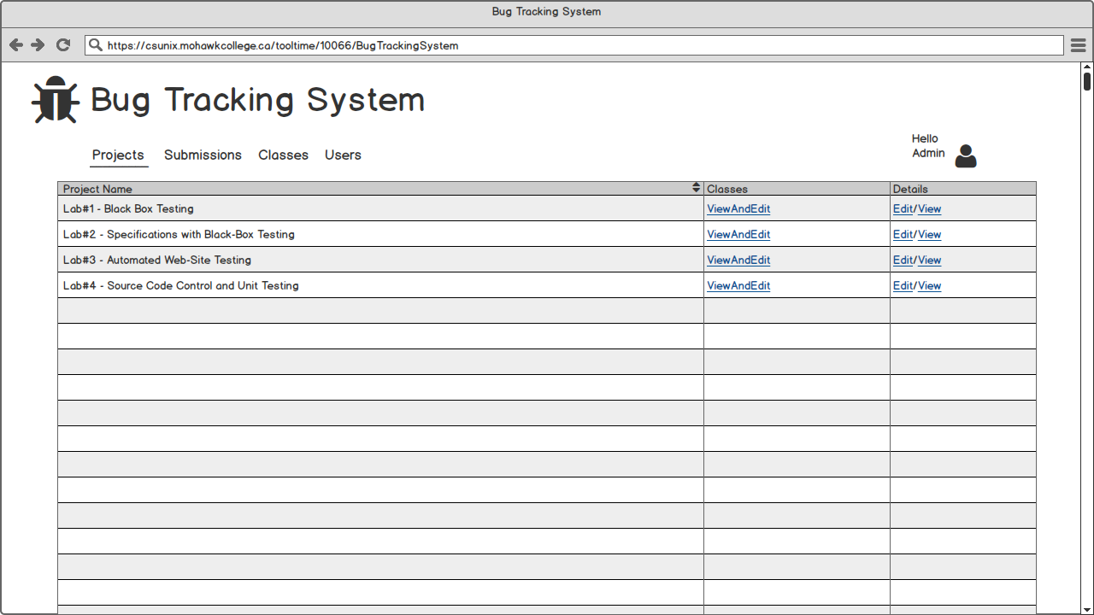 Figure 7 – Admin-Projects Session (View All)

When admin clicked View All Projects, all projects in this system will be list.

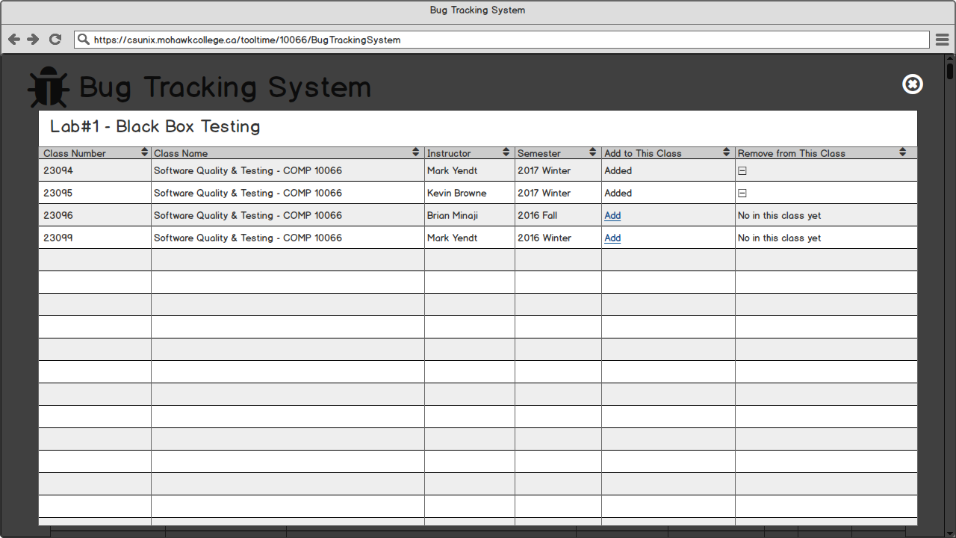Figure 8 – Admin-Projects Session (Edit Lab 1 Classes)

When admin clicked ViewAndEdit, all classes will be listed. Admin can add/remove corresponding project to/from any classes.

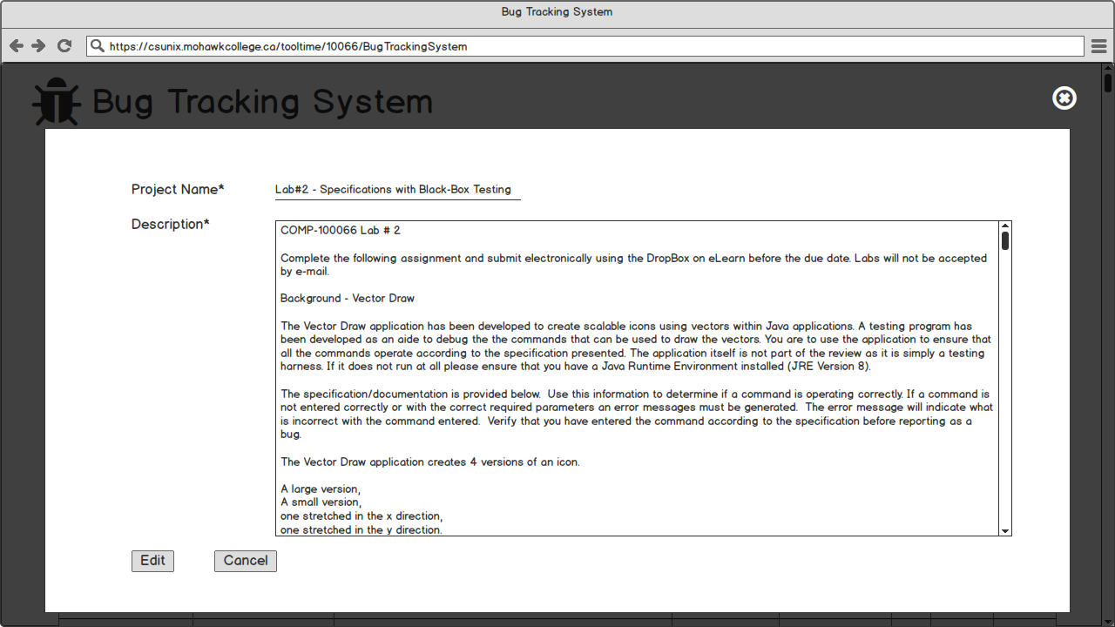Figure 9 – Admin-Projects Session (Edit Lab 2 Content)

When admin clicked Edit, the corresponding Project Name and Description will be showed and can be edit.

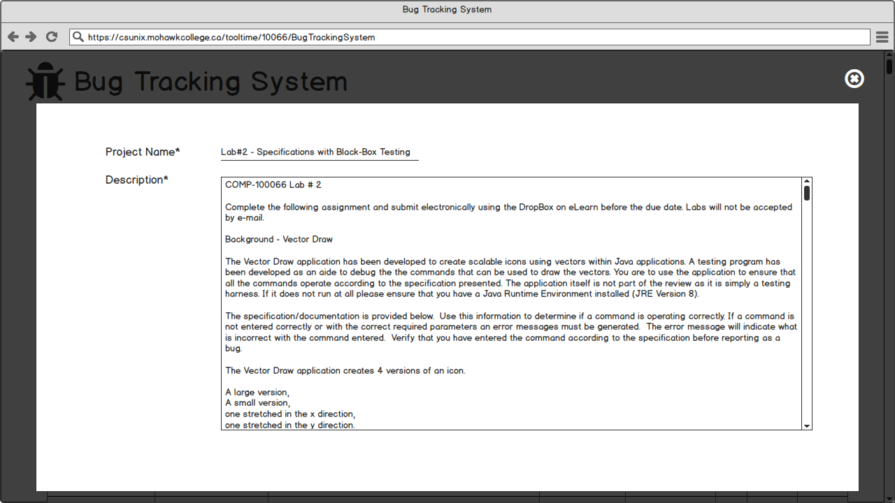Figure 10 – Admin-Projects Session (View Lab 2 Content)

When admin clicked View, the corresponding Project Name and Description will be showed.

Admin – Submissions Session Figure 11 – Admin Logged-in (Submissions Hover)

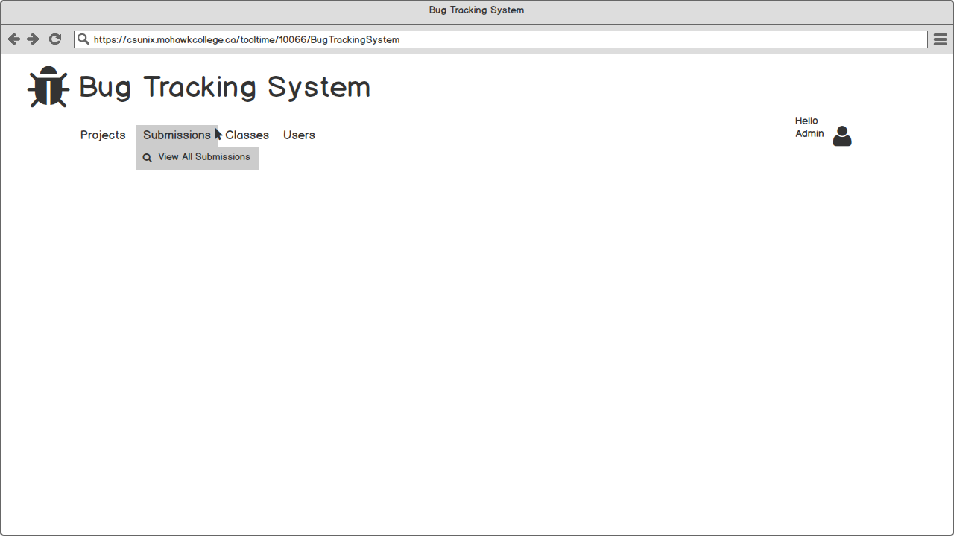

Shows what permission and functionality admin have in Submissions session

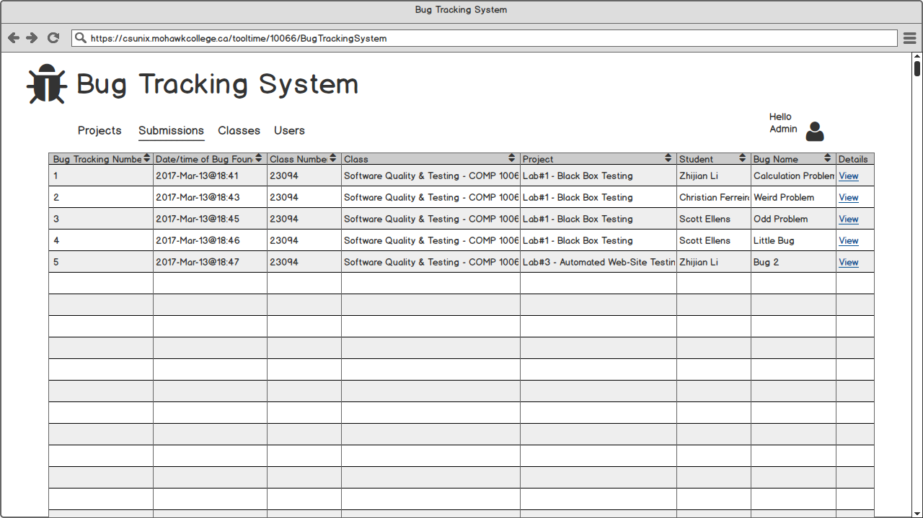Figure 12 – Admin- Submissions Session (View All)

When admin clicked View All Submissions, all submissions in this system will be list.

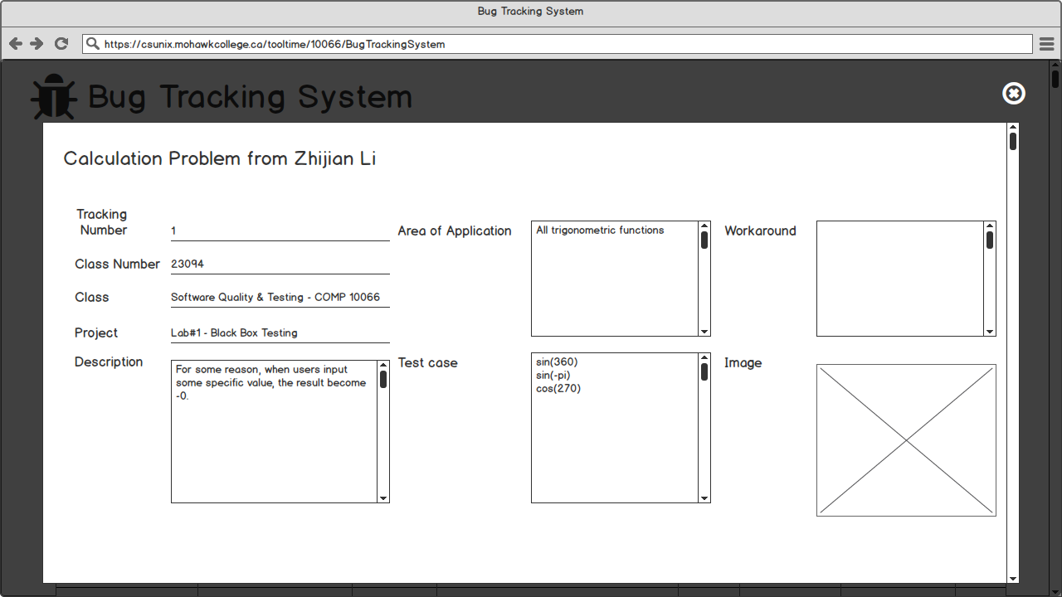Figure 13 – Admin-Submissions Session (View Entry Details (Top))

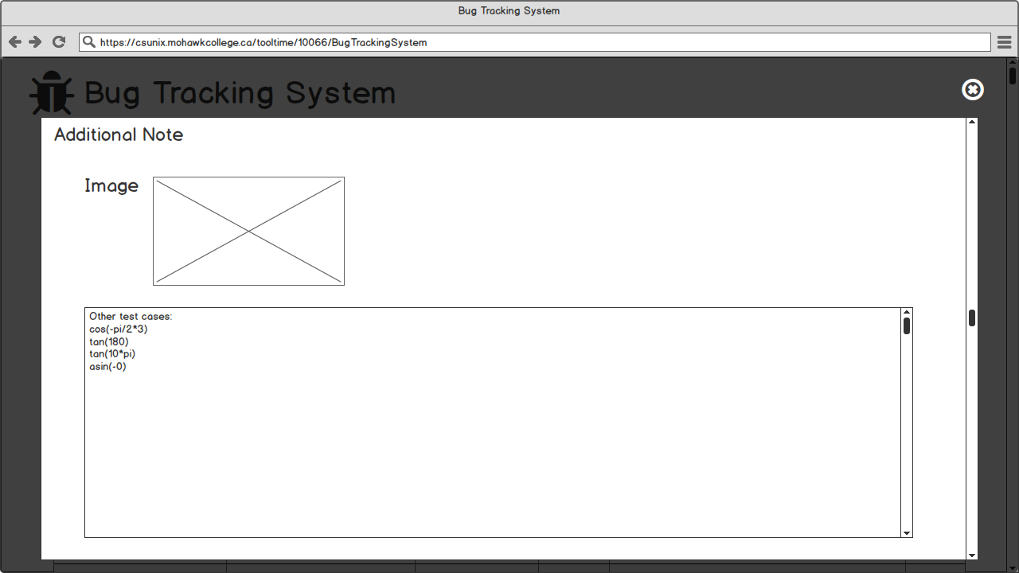Figure 14 – Admin- Submissions Session (View Entry Details- Additional Note(Bottom))

As figure 11~12 shown, when admin clicked View, the corresponding submission detail will be showed including the main property and additional note .

Admin – Classes Session 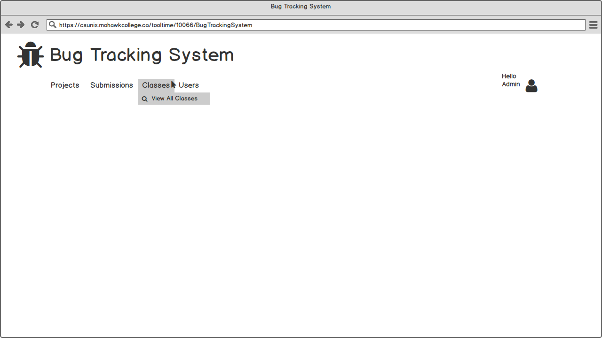Figure 15– Admin Logged-in (Classes Hover)

Shows what permission and functionality admin have in Classes session

1. View All Classes

Figure 16 – Admin- Classes Session (View All)

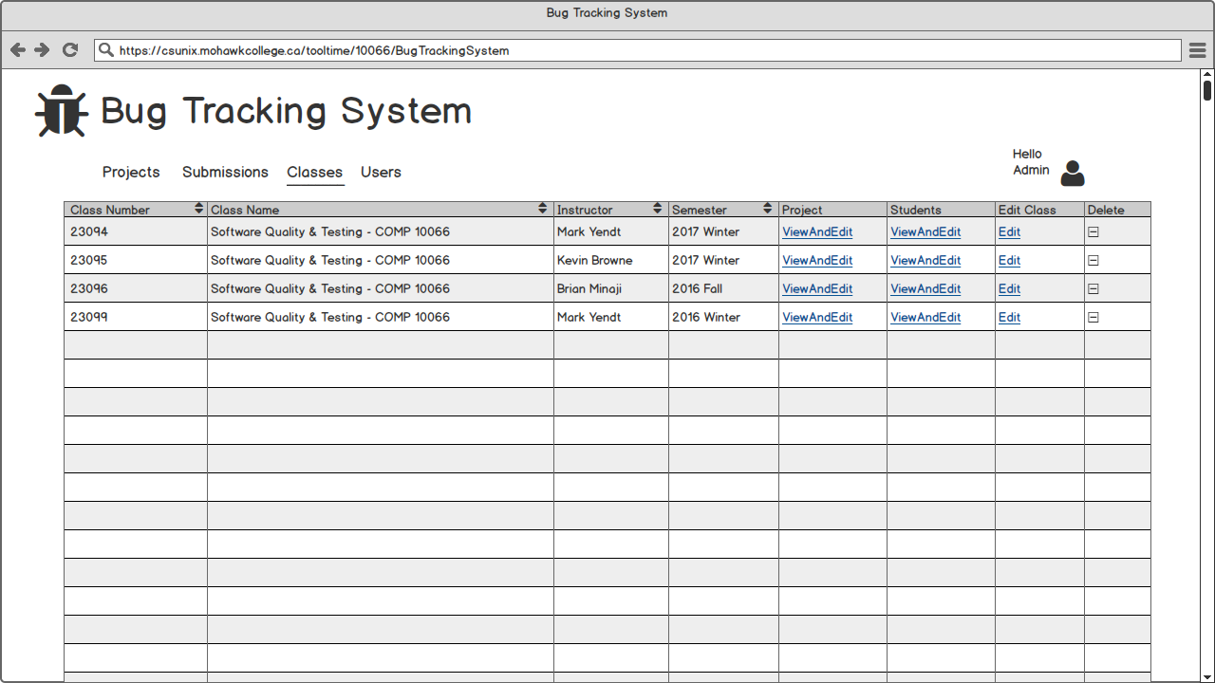

When admin clicked View All Classes, all classes in this system will be list. There are three options

1. ViewAndEdit Projects in Class
2. ViewAndEdit Students in Class
3. Edit Class,

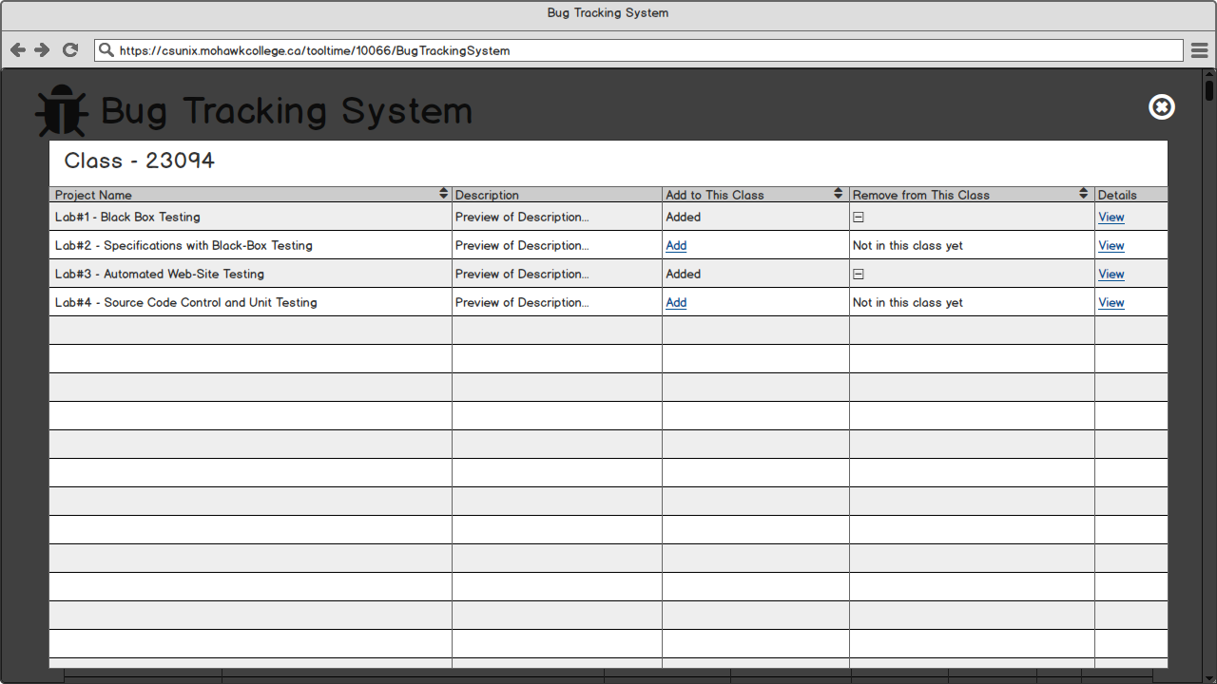Figure 17 – Admin-Classes Session (View Projects in Class 23094)

When admin clicked ViewAndEdit under Project column, all projects will be listed. Admin can add/remove any project to/from the corresponding classes. If View is clicked, corresponding project detail will be showed, like this

Figure 18 – Admin-Classes Session (View All Students in Class 23094)

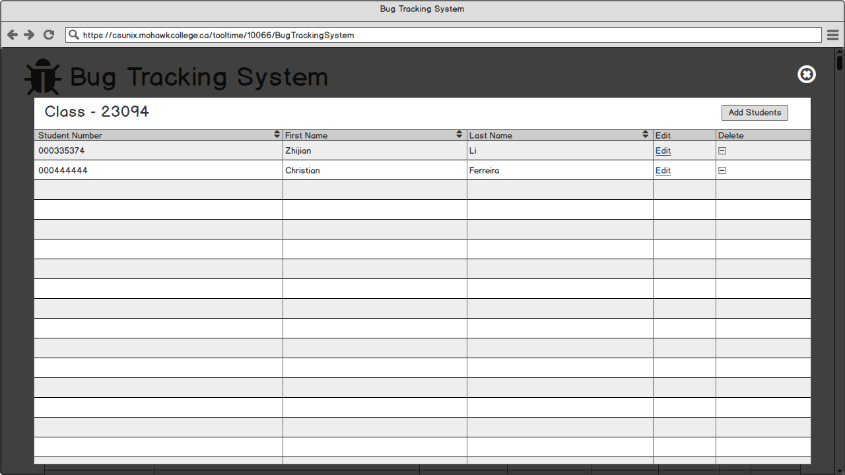

When admin clicked ViewAndEdit under Students column, all students in the corresponding class will be listed. Admin can add/remove any student to/from the corresponding classes. If Add Student is clicked, Figure 19 will be showed.

Figure 19 – Admin-Classes Session (Add Students in Current Class)

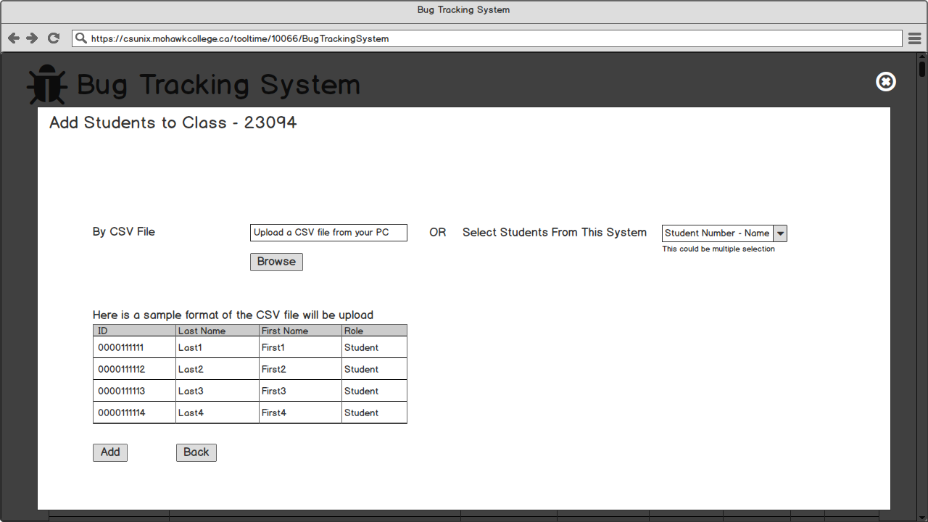

Admin can either add students by uploading a CSV files or selecting student in a dropdown list.

Figure 20 – Admin-Classes Session (Edit Class23094)

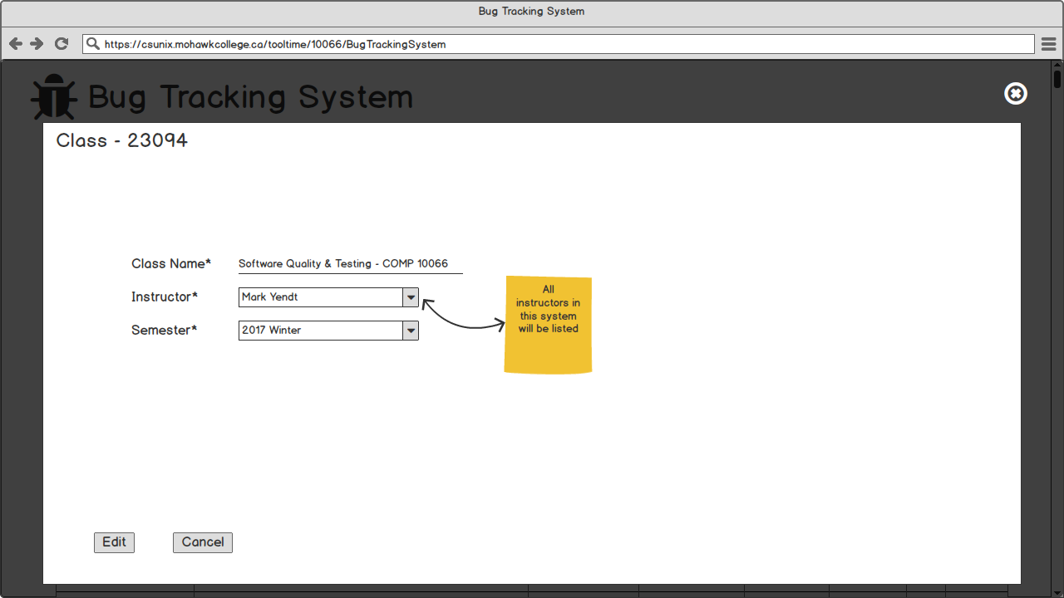

When admin clicked Edit under Edit Class column, a form is showed and corresponding details are filled.

Admin – Users Session Figure 21 – Admin Logged-in (Users Hover)

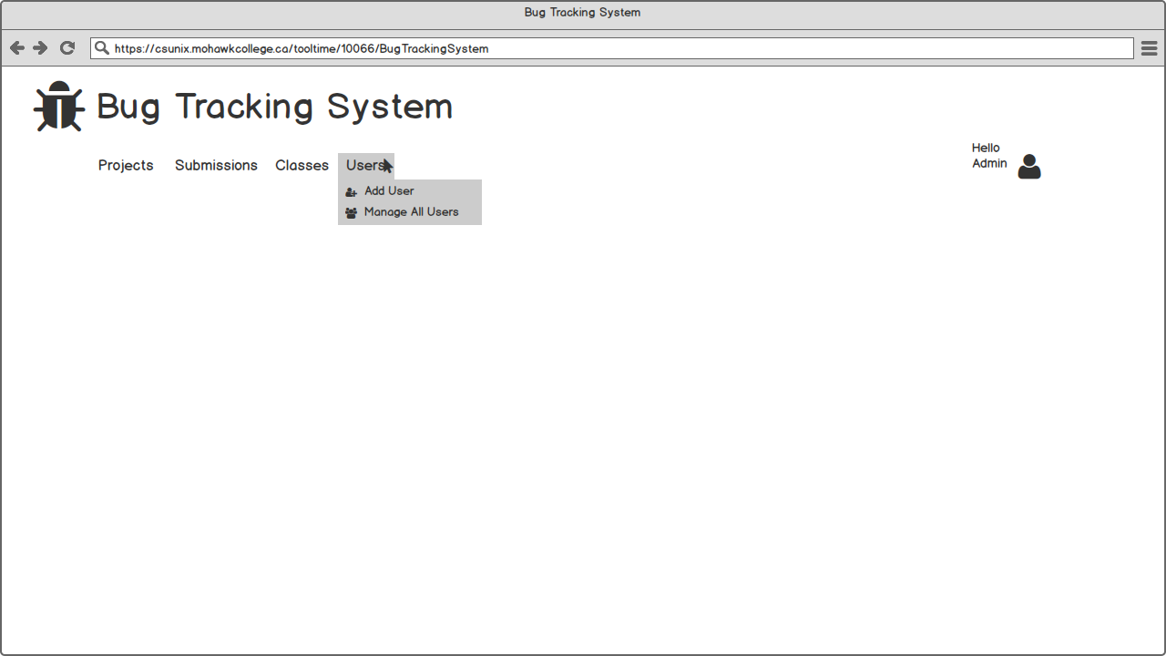

Shows what permission and functionality admin have in Users session

1. Add User (There are two ways to add users)
   1. Manually
      * Add one student
      * Add one Instructor
   2. Using a CSV file

1. Manage All Users

Figure 22 – Admin-Users Session (Add Student)

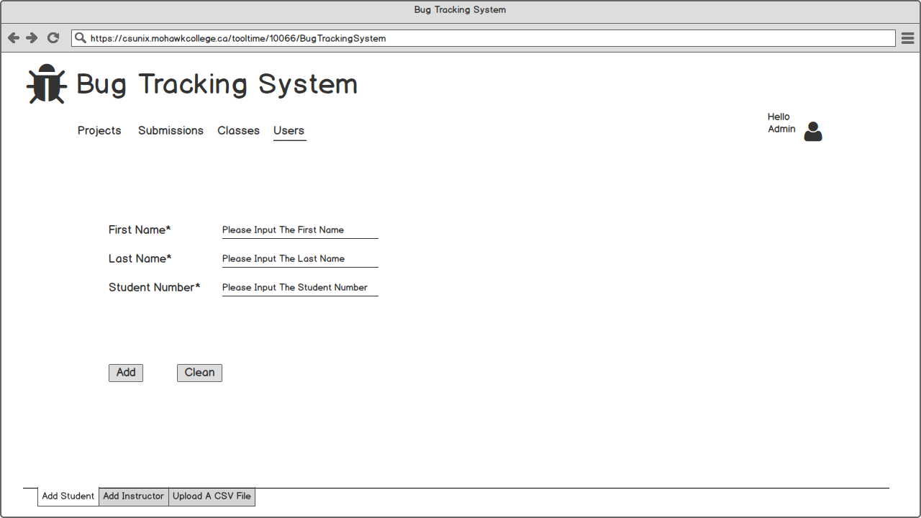

Figure 23 – Admin-Users Session (Add Instructor)

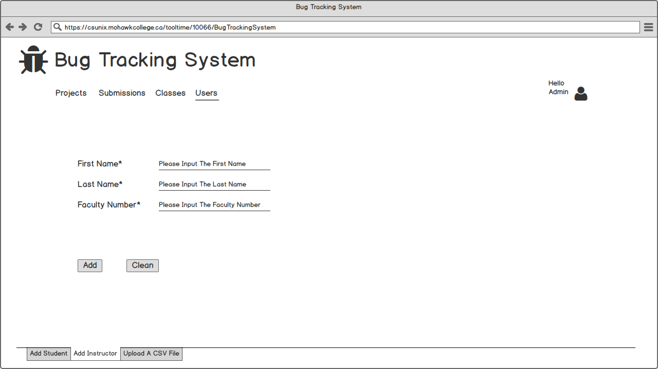

As figure 22-23 shown, fields First Name, Last Name, Faculty/Student Number are mandatory.

Figure 24 – Admin-Users Session (Upload A CSV File)

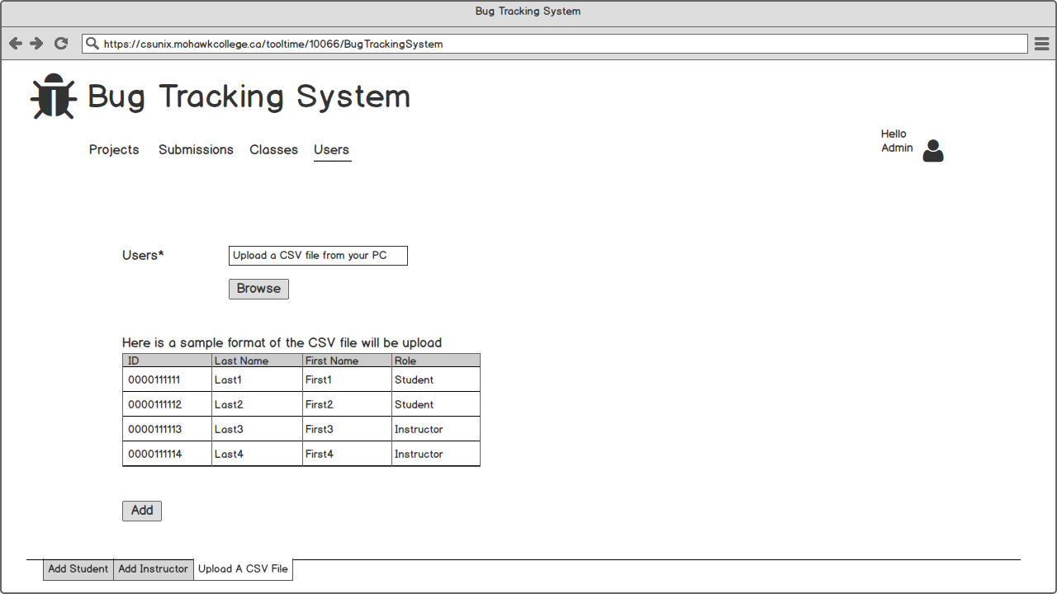

Figure 25 – Admin-Users Session (Manage All Users)

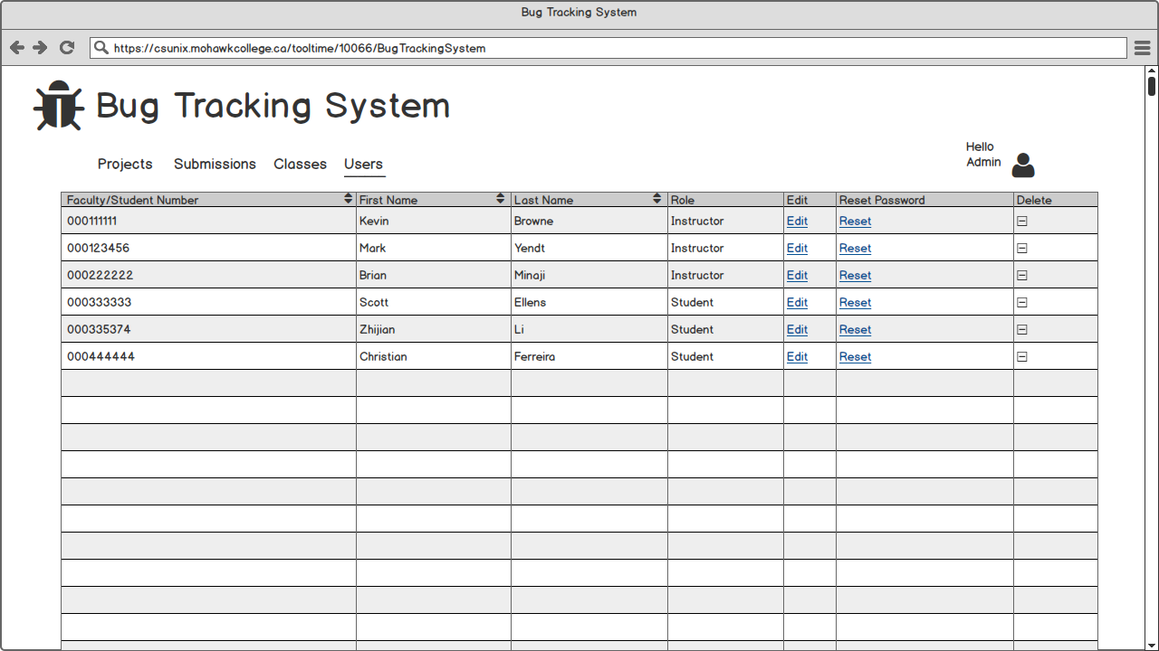

When Manage All Users is clicked, all users in this system will be listed. Admin can edit user information, reset user password and remove users from this system.

Figure 26 – Admin-Users Session (Manage All Users)

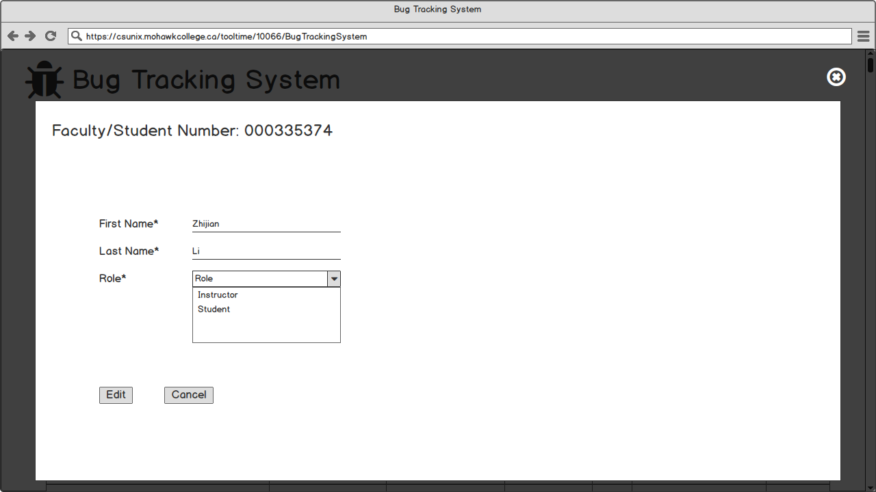

When Edit is clicked, a form filled with corresponding student information is showed.

Instructor – Projects Session

Figure 27 – Instructor Logged-in (Projects Hover)

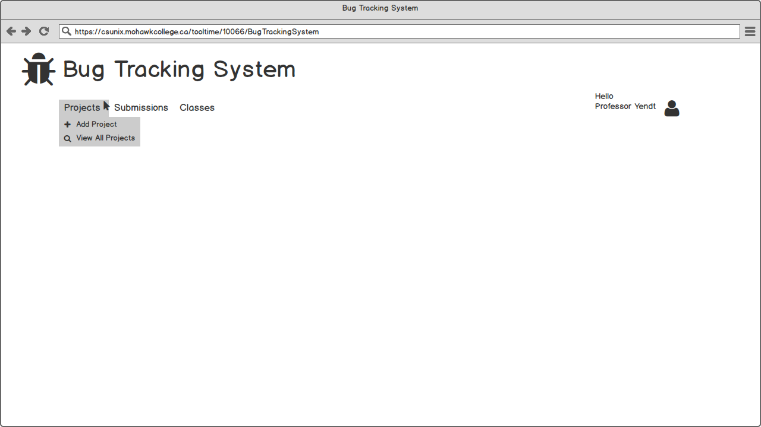

Shows what permission and functionality Instructor have in Projects session

1. Add Project
2. View All Projects

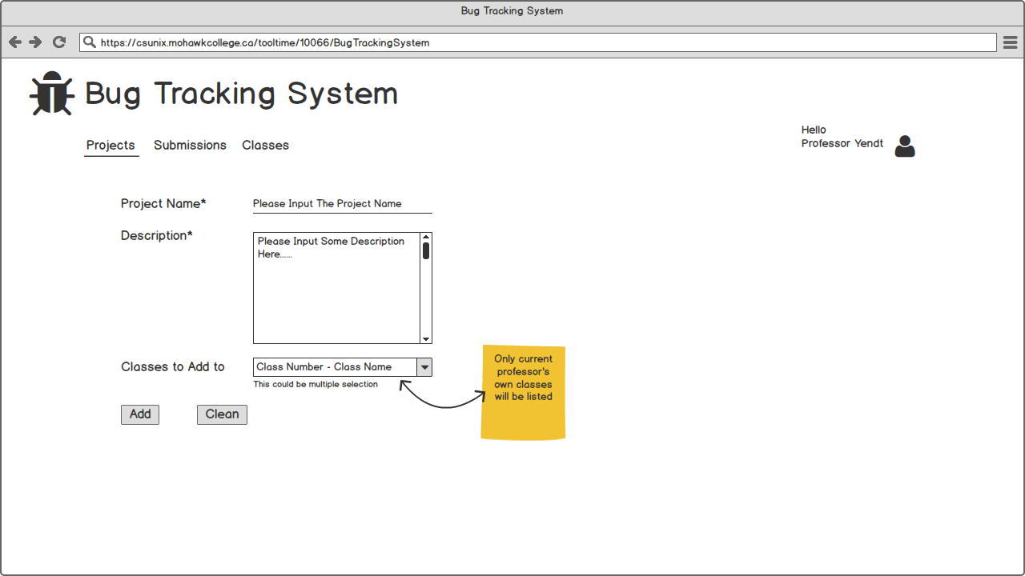 Figure 28 – Instructor -Projects Session (Add)

When instructor clicked Add Project, a form is showed. Project Name and Description are mandatory field, and the project can be assigned to instructor’s own classes later.

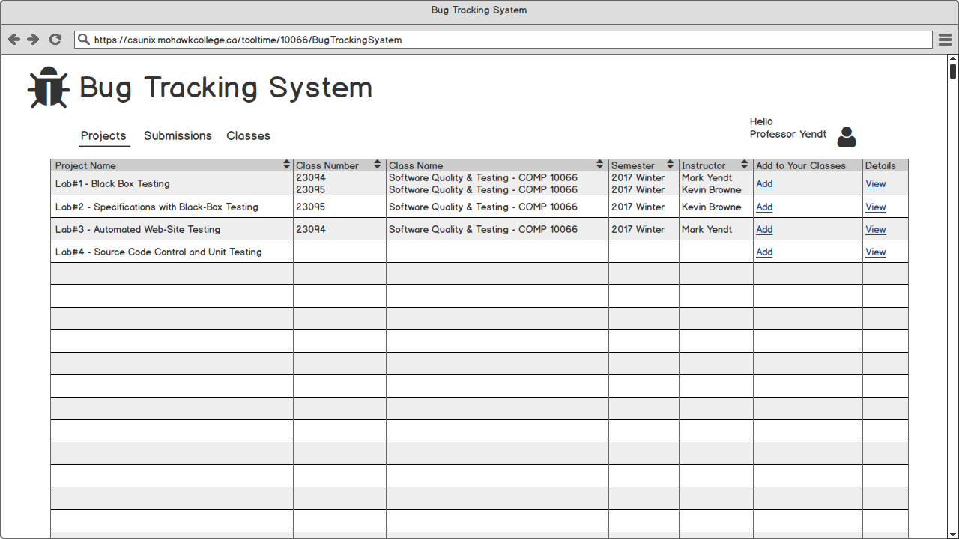 Figure 29 – Instructor -Projects Session (View All)

When instructor clicked View All Projects, all projects in this system will be list. They can either add projects to their class or view the project detail.

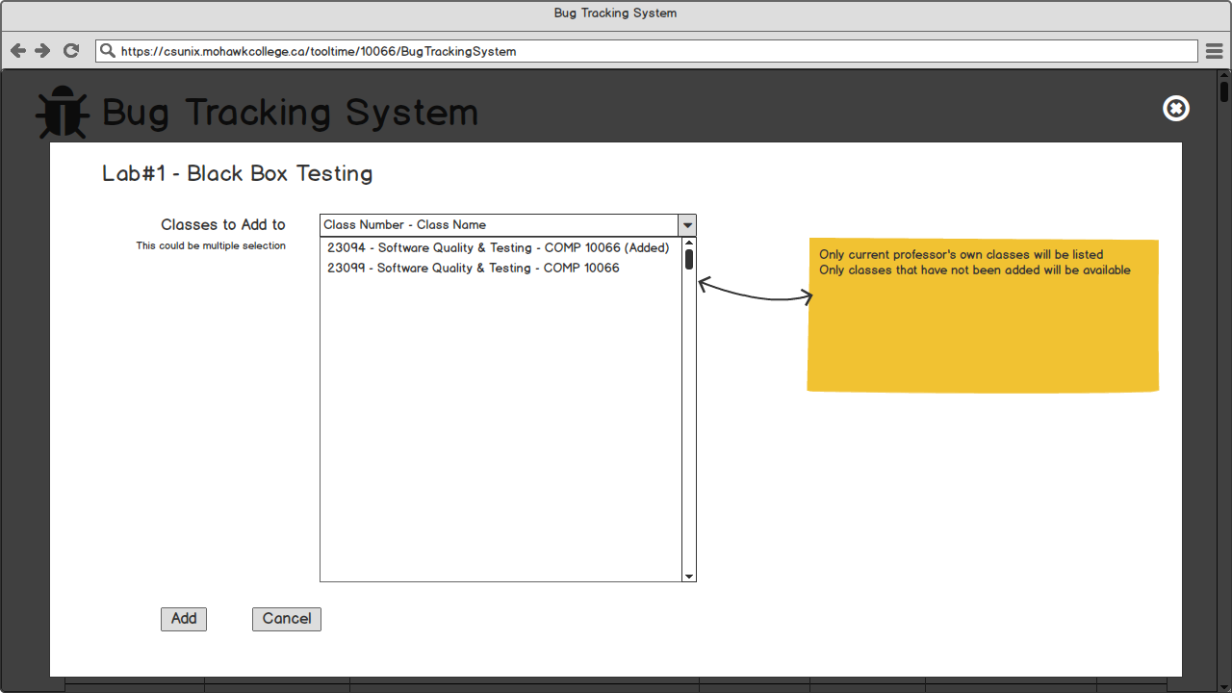Figure 30 – Instructor-Projects Session (Add Lab 1 to Instructor Classes)

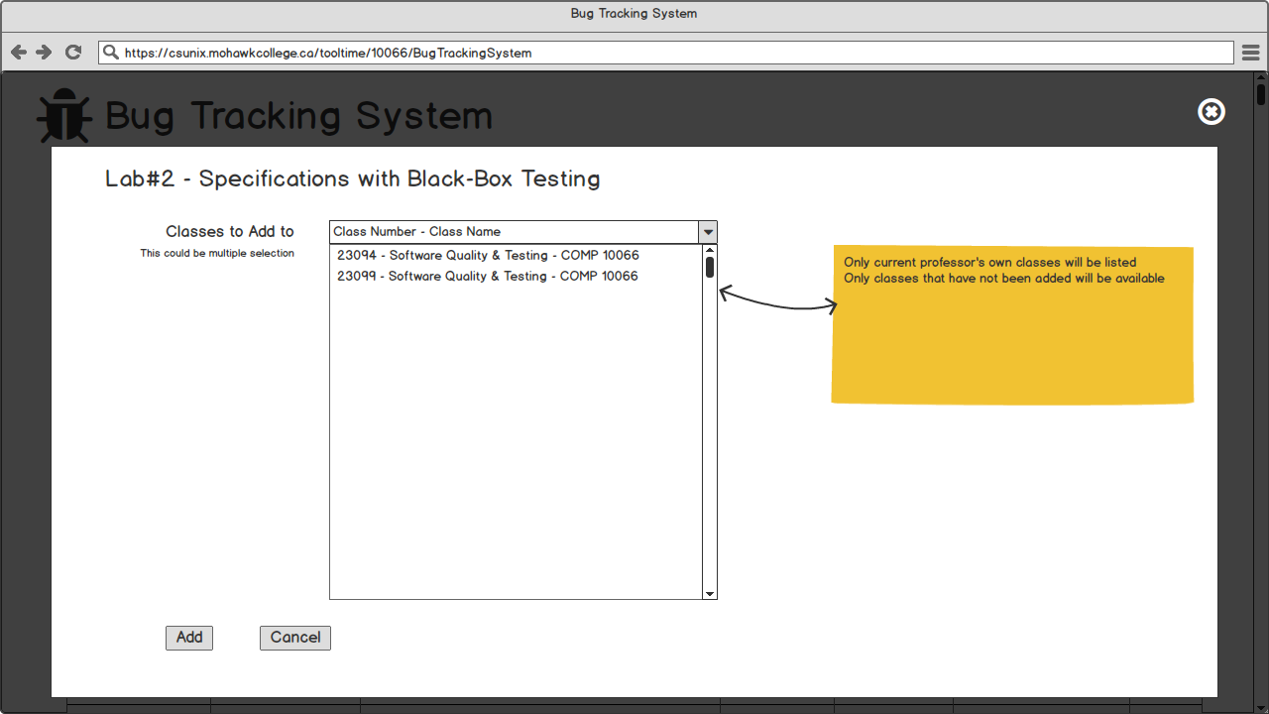Figure 31 – Instructor-Projects Session (Add Lab 2 to Instructor Classes)

Figure 32 – Instructor-Projects Session (View Lab 2 Details)

Instructor – Submission Session

Figure 33 – Instructor Logged-in (Submissions Hover)

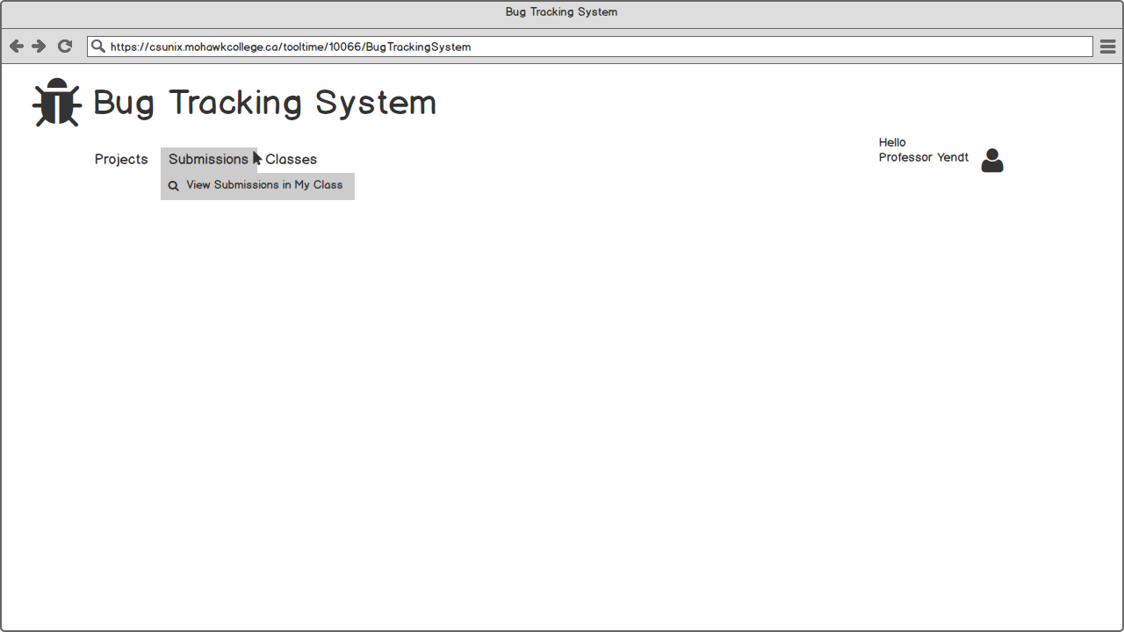

Shows what permission and functionality Instructor have in Submissions session

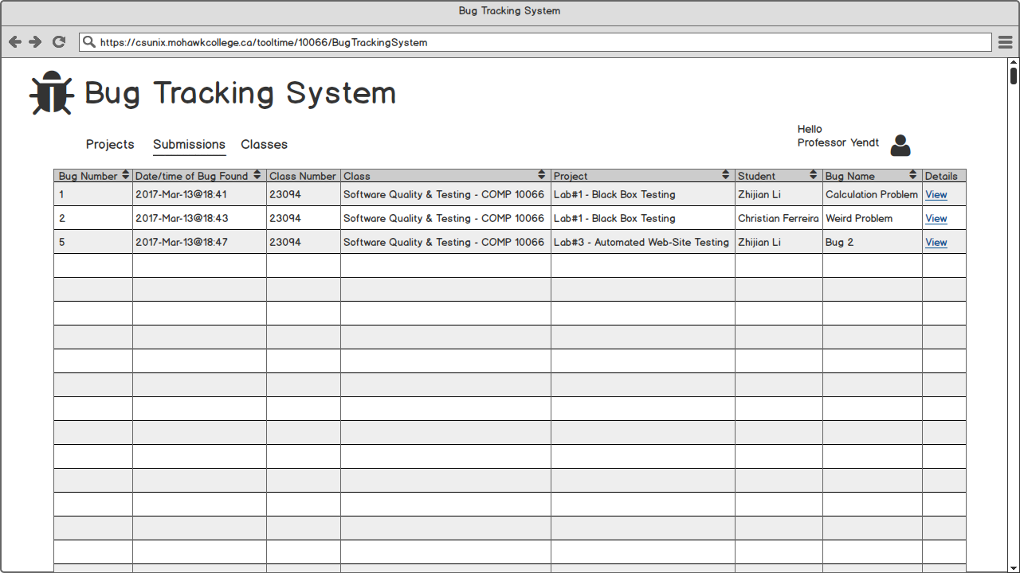Figure 34 – Instructor - Submissions Session (View All)

When Instructor clicked View All Submissions, all submissions of projects that assigned to his/her classes will be listed. Instructor can either view the details of submissions

Figure 35 – Instructor -Submissions Session (View Entry Details (Top))

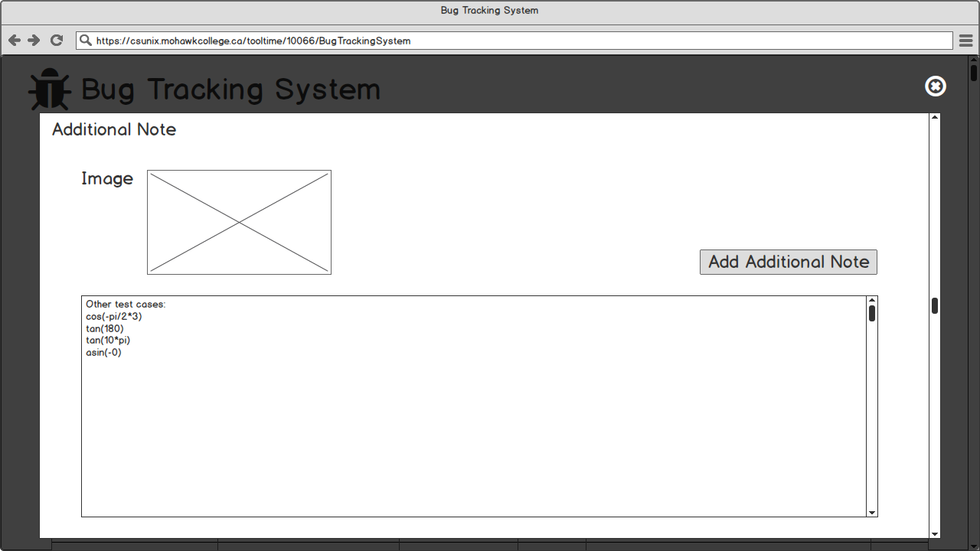Figure 36 – Instructor - Submissions Session (View Entry Details- (Bottom))

As figure 35~36 shown, when Instructor clicked View, the corresponding submission detail will be showed including the main property and Additional Note.

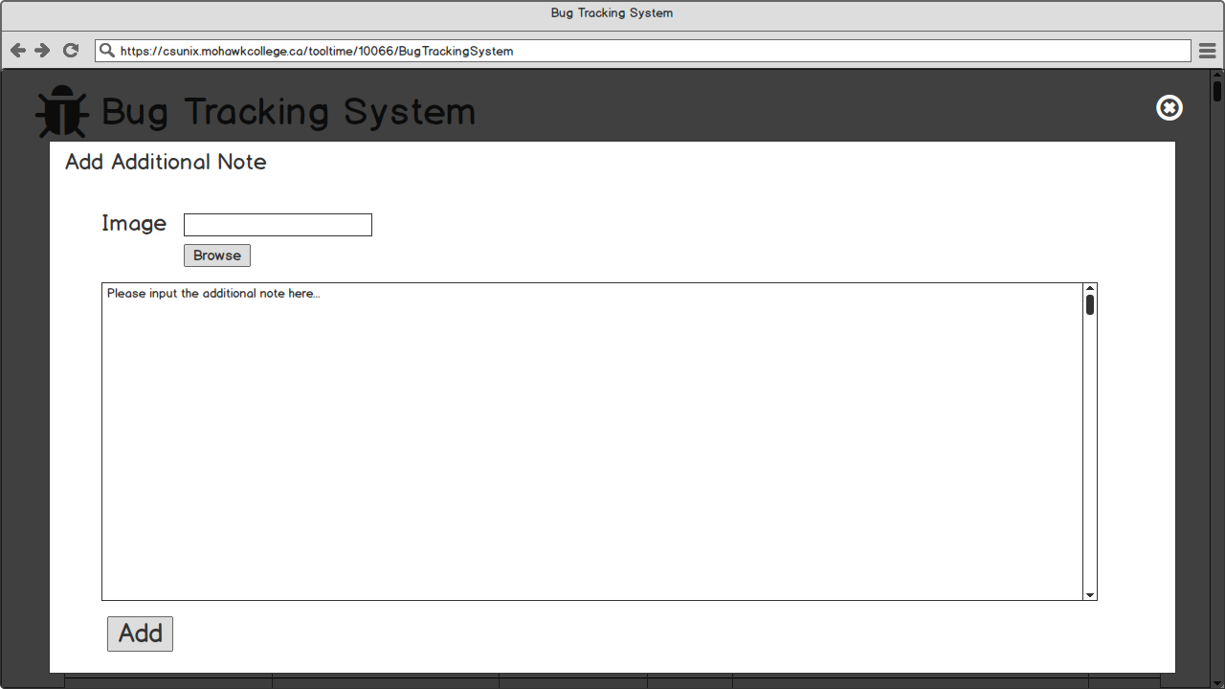Figure 37 – Instructor - Submissions Session (Add Additional Note)

When Instructor clicked Add Additional Note, a corresponding form will be showed.

Instructor – Classes Session 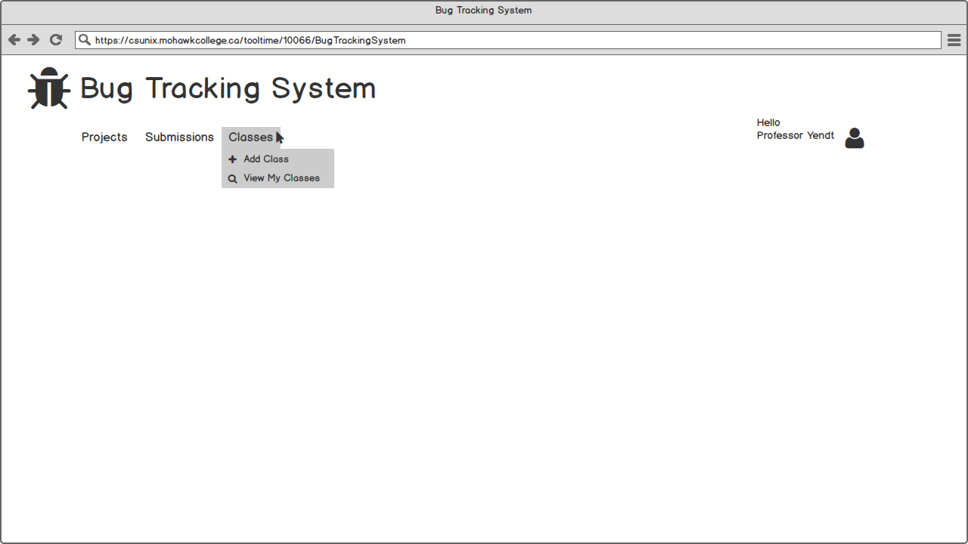Figure 38 – Instructor Logged-in (Classes Hover)

Shows what permission and functionality Instructor have in Classes session

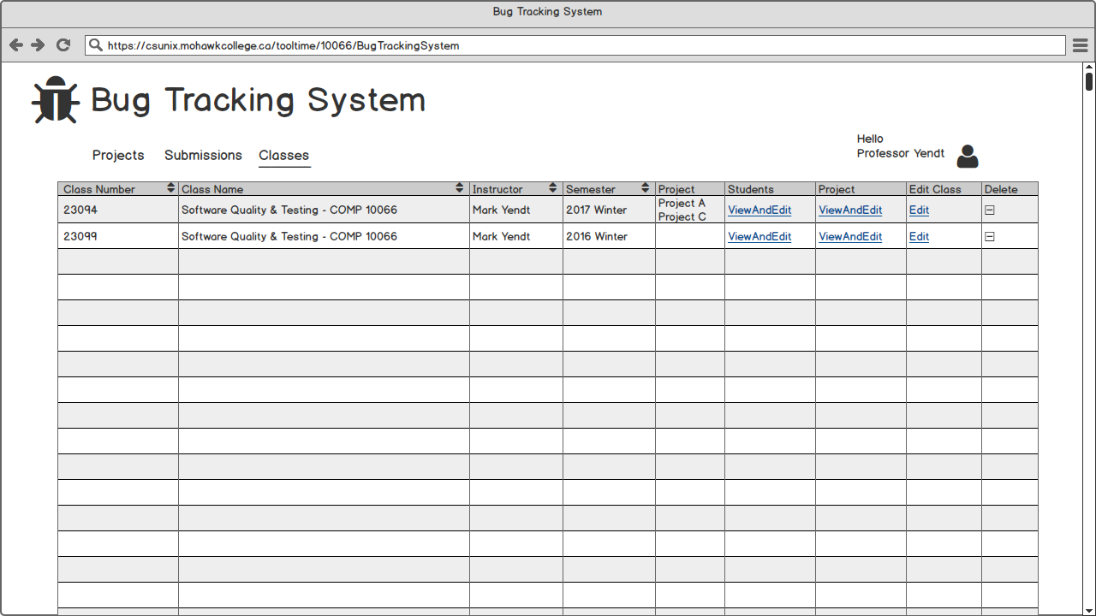Figure 39 – Instructor-Classes Session (View All)

When instructor clicked View My Classes, all current instructor’s own classes will be list. They can either ViewAndEdit all students of a class, add/remove Projects to/from a class or Edit Class. Figure 40 – Instructor-Classes Session (View All Students in Class 23094)

When Add Students is clicked, a page will be showed like this

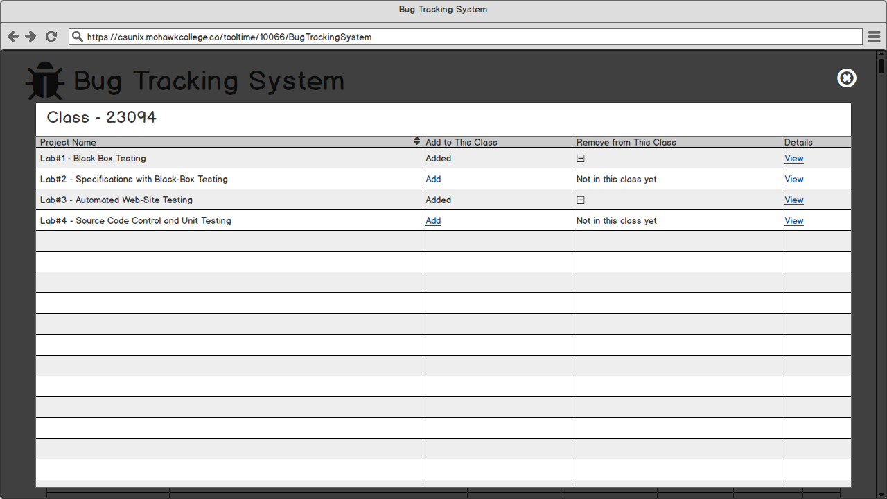Figure 41 – Instructor-Classes Session (ViewAndEdit Projects in Class 23094)

When View is clicked, details of the corresponding project will be showed like this

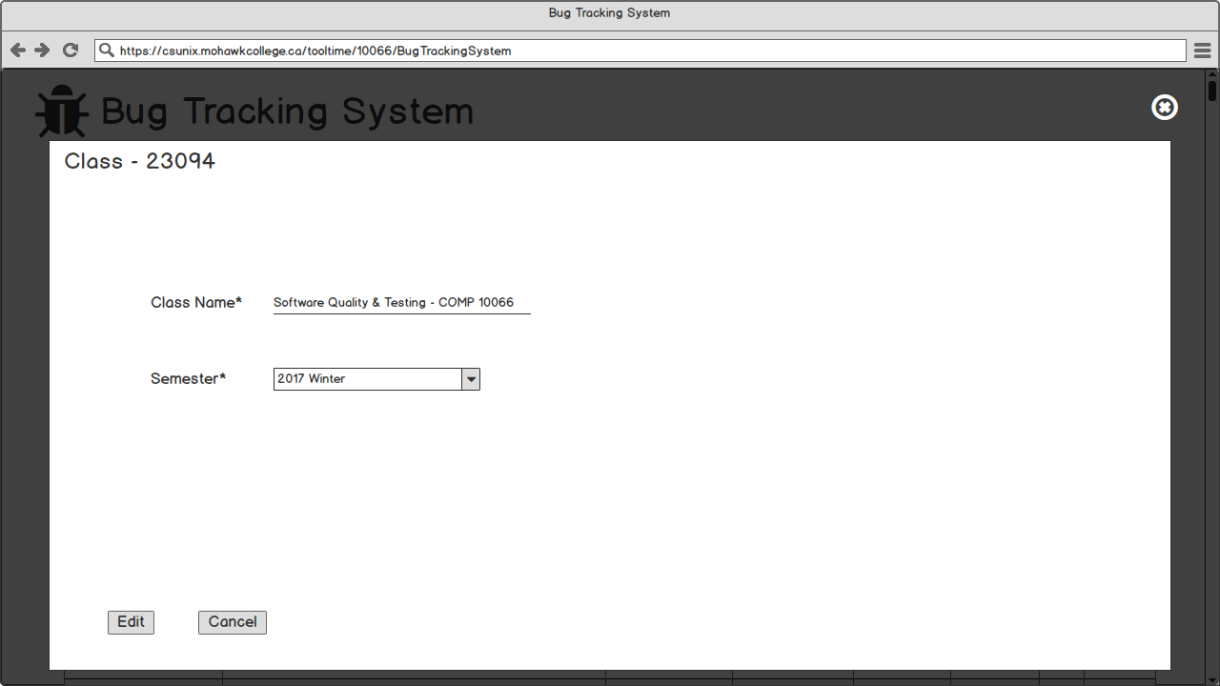 Figure 42 – Instructor-Classes Session (Edit Class)

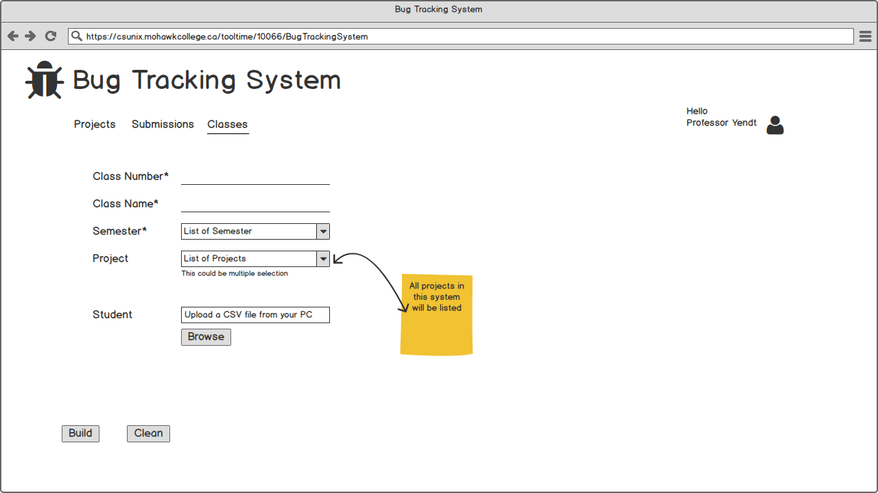 Figure 43 – Instructor-Classes Session (Add Class)

When the instructor clicked Add Class, he/she can build an own class manually

Student – Submission Session

Figure 44 – Student Logged-in (Submissions Hover)

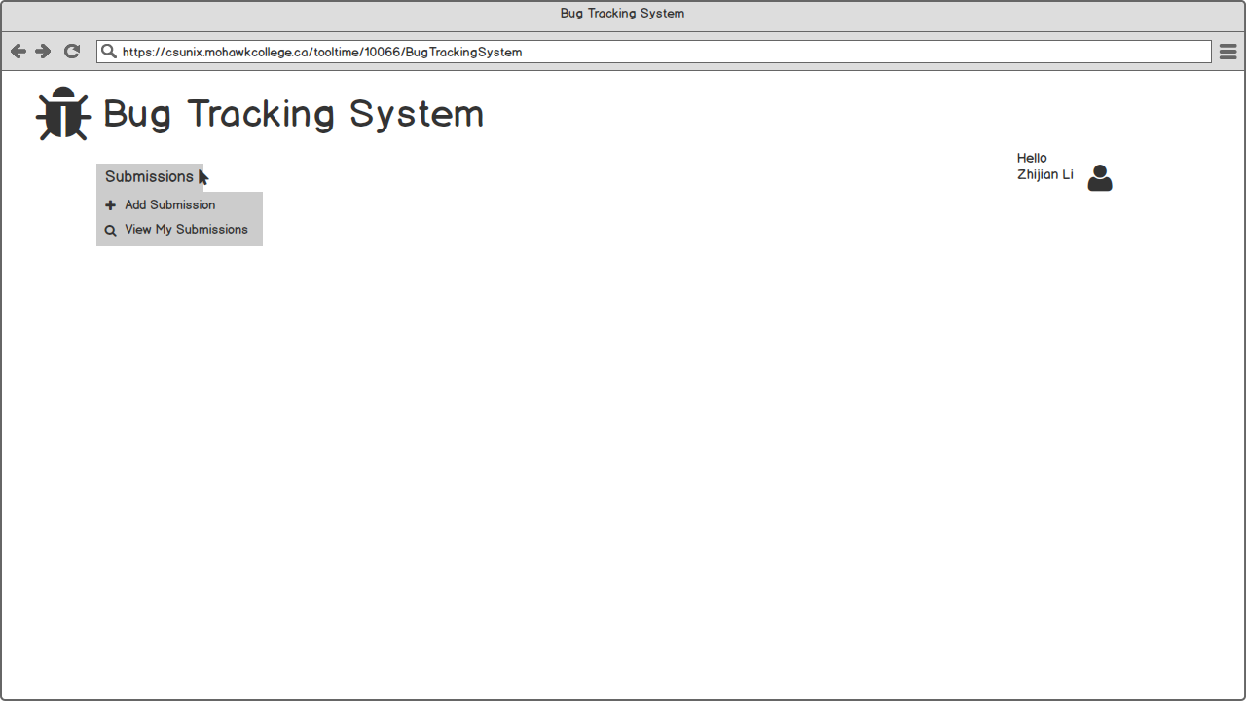

Students can either add submission to the project they assigned or view their own submissions.

Figure 45 – Student-Submissions Session (Add)

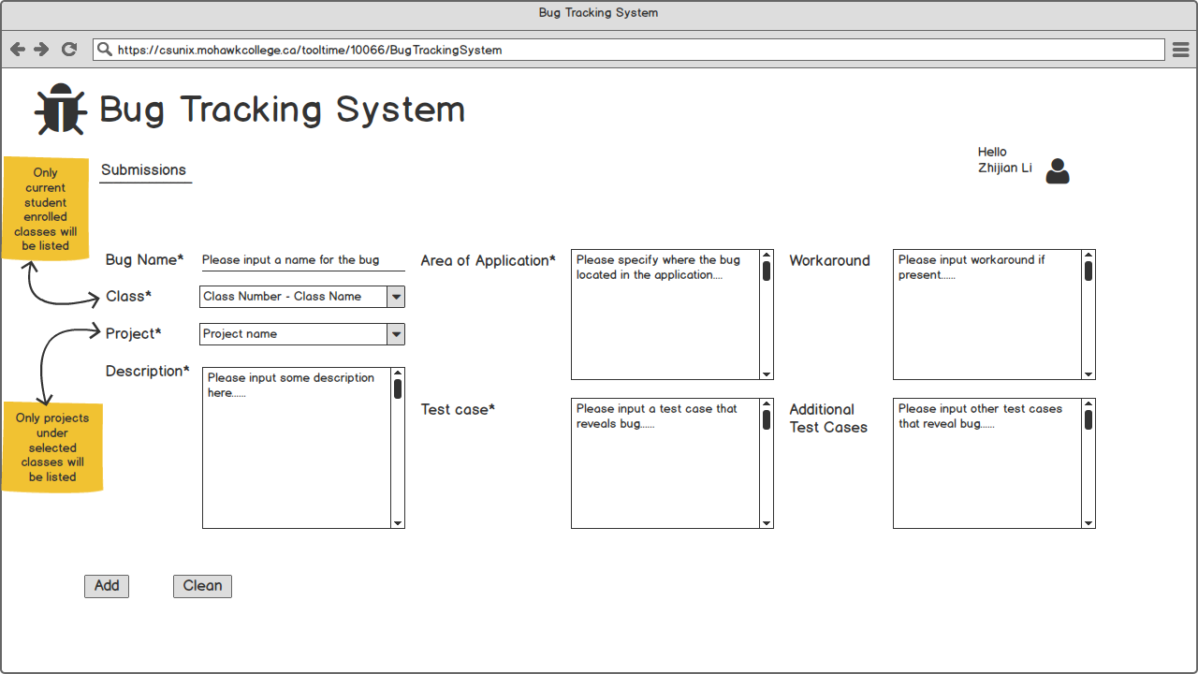

All fields with asterisk are mandatory

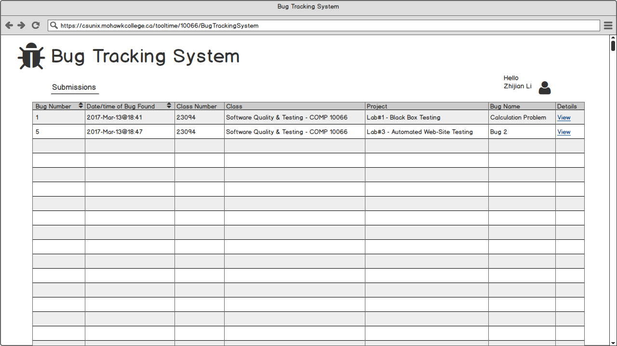Figure 46 – Student-Submissions Session (View All)

All current student’s own submissions will be listed. Student can either view submissions details or add Additional Note.

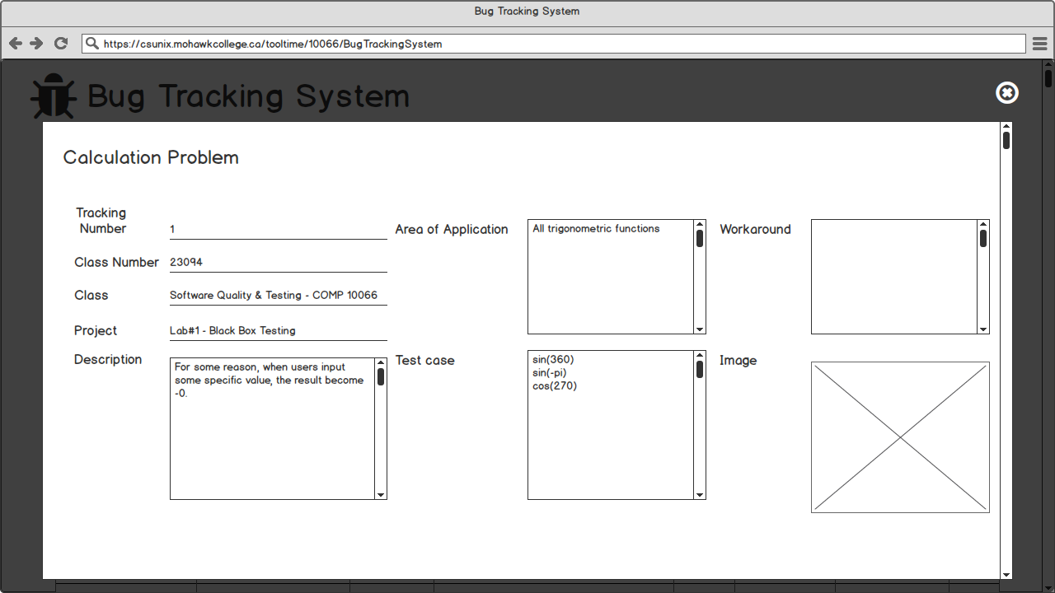Figure 47 – Student - Submissions Session (View Entry Details (Top))

Figure 48 – Student - Submissions Session (View Entry Details- Clarification (Bottom))

As figure 47~48 shown, when Student clicked View, the corresponding submission detail will be showed including the main property and Additional Note. When Add Additional Note clicked

Account Hover

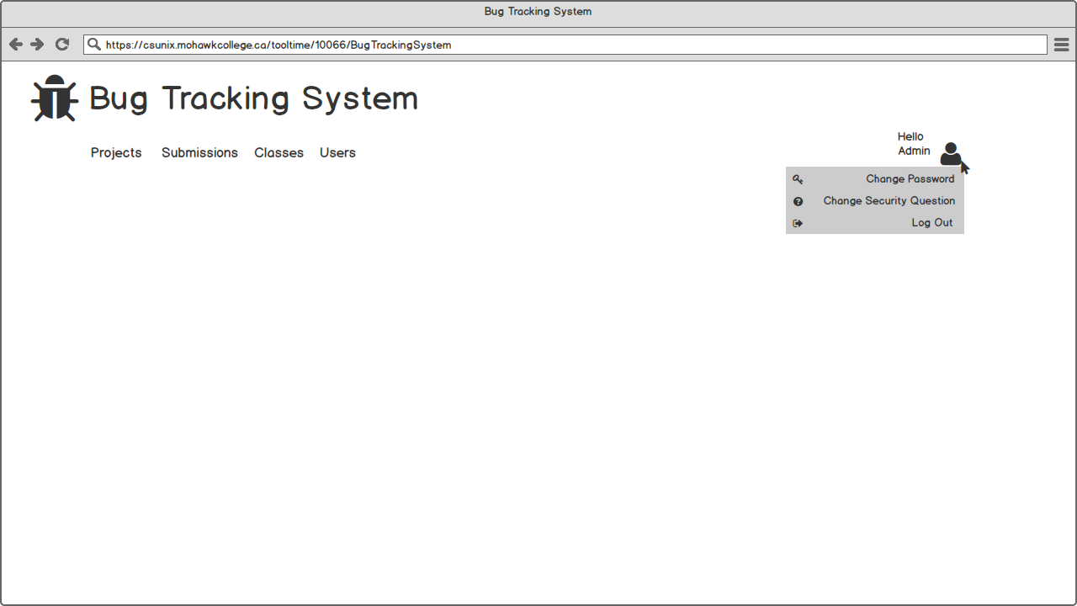Figure 49

When admin hover the user icon

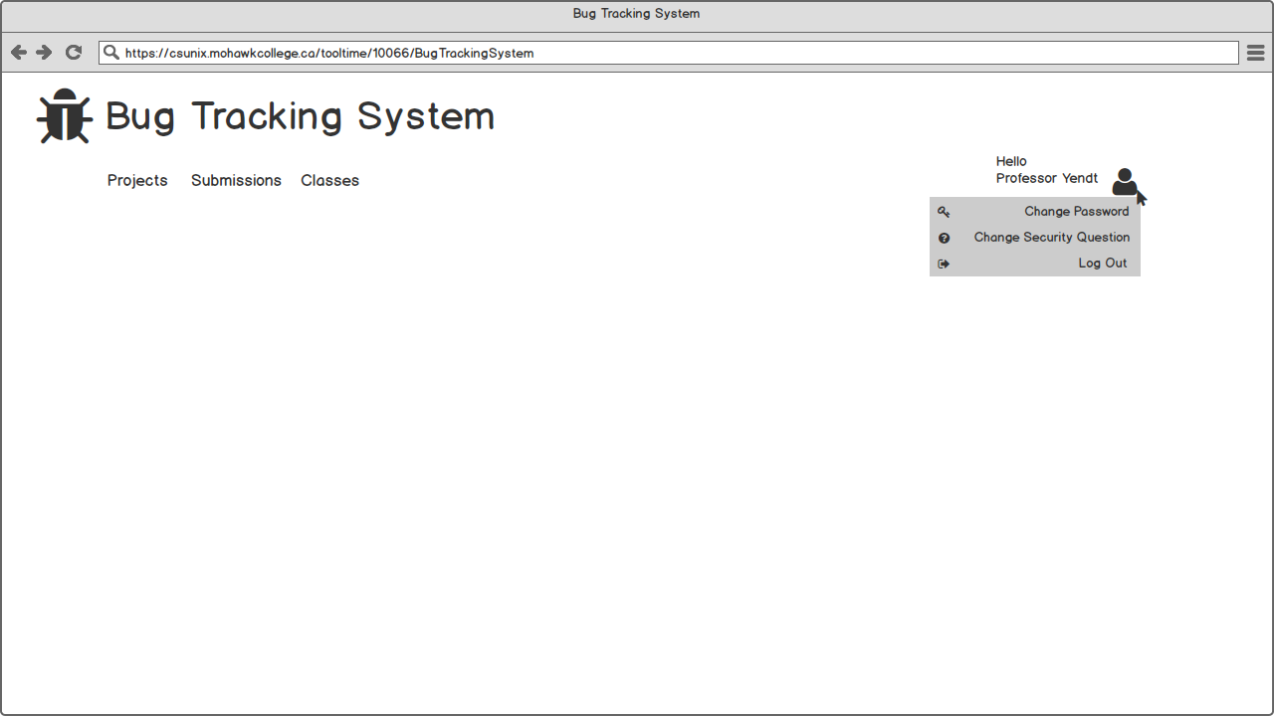Figure 50

When Instructor hover the user icon

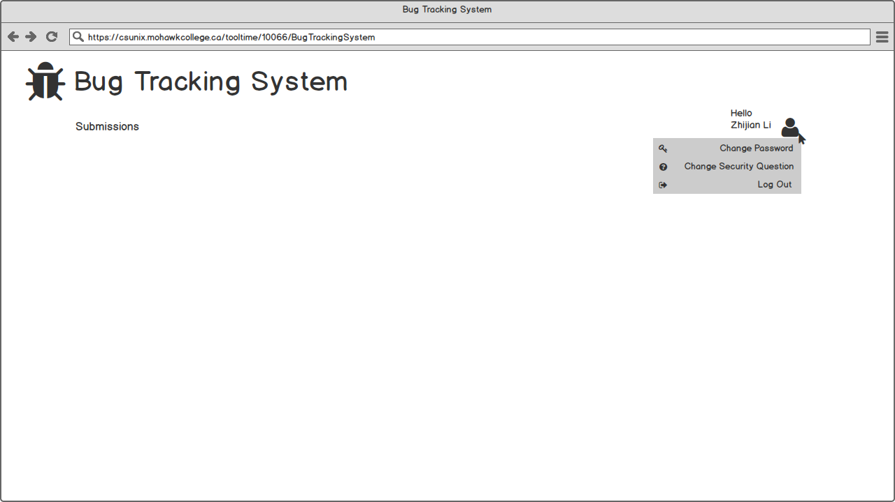Figure 51

When student hover the user icon

All users can be able to independently control their own passwords and security question.

* Change Password
* Change Security Question

Figure 52 - Changing Password

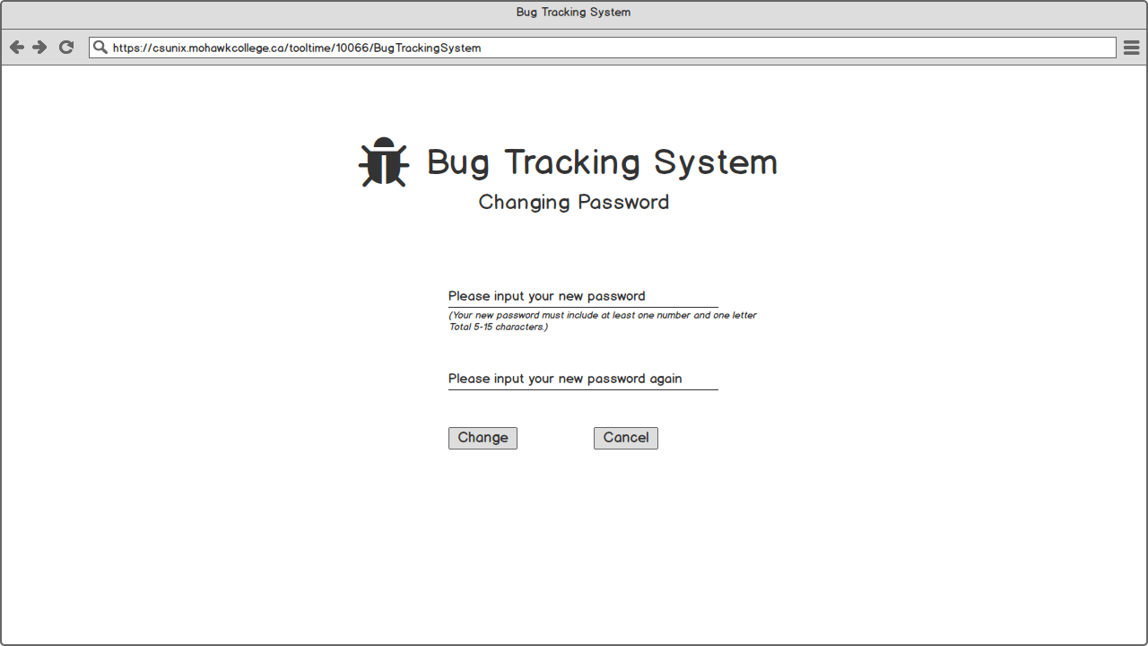

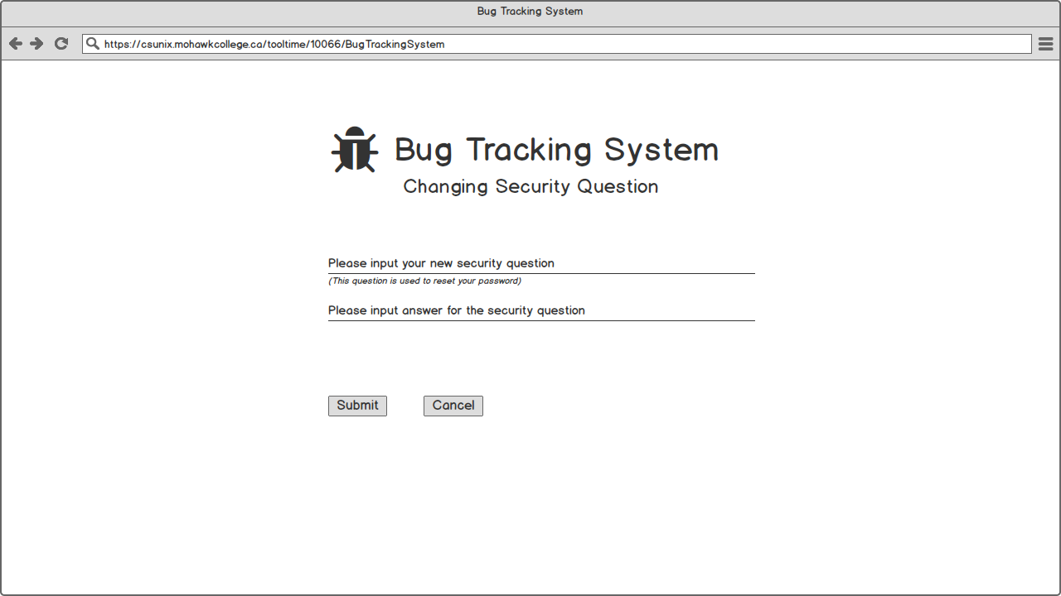 Figure 53 - Changing Security Question

Database Schema

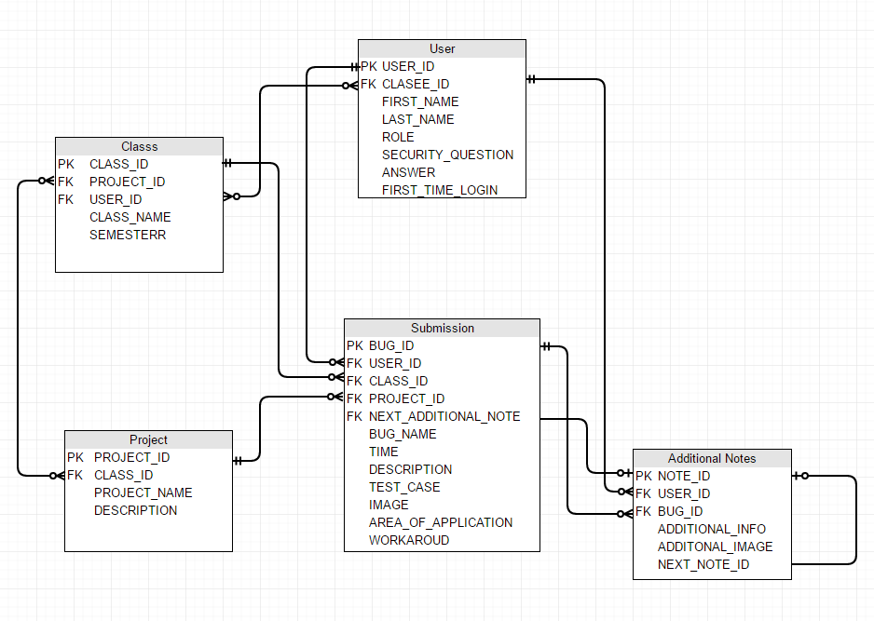

Test Plan

Selenium will be used to test the web application as follows:

* Log In/Log Out
  + Log in with correct password
  + Log in with wrong password
  + The first-time log in
  + The first-time log in after password had been reset
  + Log out
* Password
  + Admin reset password for users
  + Users change their own password
* Navigation Bar
  + Appropriate content showed based on logged-in account role
  + Appropriate content showed when different session is hover
* Project Session
  + Add Project
    - Mandatory fields
    - Only classes in the system should be list at the “Classes to Add to” field
  + View All Projects
    - All projects in the system should be showed
    - Relation between projects and classes should be corresponding
    - Projects’ content should be correct
* Submission Session
  + Add Submission
    - Mandatory fields
    - Only current student enrolled classes should be listed at the “Classes” field
    - Only projects under selected classes will be listed at the “Project” field
  + View Submission
    - If student logged in, only student’s own submissions should be listed
    - If instructor logged in, only submissions that belong to students and projects both in instructor’s own class should be listed.
    - If admin logged in, all submissions should be listed
* Class Session
  + Import Classes
    - All selected classes in Mohawk college should be listed
  + Build a Class
    - Mandatory fields
    - All instructors in this system will be listed at “Instructor” field
    - All projects in this system will be listed at “Projects” field
  + View Classes
    - If instructor logged in, only instructor s own classes should be listed
    - If admin logged in, all classes should be listed
  + Edit Classes
    - Corresponding info should be filled in fields
  + Student in Classes
    - Admin/Instructors are able to view students in all/their own class
    - Admin can add/remove any students to/from a class
* Users Session
  + Add User
    - Mandatory fields
  + Upload a CSV file
    - Data should be Import correctly
  + View Users
    - All users should be listed
    - All users can be removed
    - All users’ password can be reset
* General
  + All add-action should affect database immediately
  + All edit-action should affect database immediately
  + All delete-action should affect database immediately

Resources and Challenges

The biggest challenge for me will be keeping on track with my project’s milestone deadlines. I tend to work intensively in bursts then take long breaks where I accomplish little. I know that I will need to work on this project at a continuous pace to get everything done.

Resources for technical challenges:

* Mark Yendt - my advisor
* Stack Overflow – a useful website that solve most problems I would encounter
* Web development blogs

Project Development Plan

|  |  |
| --- | --- |
| Week1  4-Sep - 10-Sep | Set up development environment, install needed tools, Set up SQL databases with PHPMyAdmin. |
| Week2  11-Sep - 17-Sep | Developing user login system and reset/change password. |
| Week3  18-Sep - 24-Sep | Work on website view. Get all the navigation bar and tabs going |
| Week4  25- Sep - 1-Oct | Work on Projects session -- Add Project |
| Week5  2-Oct - 8-Oct | Work on Projects session -- View All Projects |
| Week6  9-Oct - 15-Oct | Work on Submissions session -- Add Submission |
| Week7  16-Oct - 22-Oct | Work on Submissions session -- View Submission |
| Week8  23-Oct - 29-Oct | Work on Classes session -- Import Classes, Build a Class |
| Week9  30-Oct- 5-Nov | Work on Classes session -- View Classes, Edit Classes |
| Week10  6-Nov - 12-Nov | Work on Classes session – CRUD Student in Classes |
| Week11  13-Nov - 19-Nov | Work on Users session -- Add User |
| Week12  20-Nov -26-Nov | Work on Users session -- Upload a CSV file, View Users |
| Week13  27-Nov - 3-Dec | Final project testing and test use in all browsers. |
| Week14  4-Dec - 10-Dec | Come up with a presentation of final project for class. |